Practical - 4
Practical Title: JavaScript DOM Manipulation, Event Handling, and UI Interactivity

Add dynamic UI components such as collapsible FAQ, modal popup, image/content slider, notification banner, hamburger menu, and light/dark theme switcher using JavaScript.

Theory
1. How does the layout adapt for mobile, tablet, and desktop screens?
- The website uses CSS media queries to make the layout responsive for different screen sizes.
- On desktop screens, the login page uses a two-column layout where the left side displays the background image and the right side contains the login form.
- On tablet screens, the width of the login container is reduced using max-width, and the content width and font sizes are adjusted.
- On mobile screens, the two-column layout changes into a single-column layout using grid-template-columns: 1fr.
- The left section gets a fixed height, while the login section is placed below it.
- Padding, font sizes, and element widths are also reduced on smaller screens to maintain readability and prevent horizontal scrolling.
2. Which layout technique is used and why?
- The main layout uses CSS Grid.
- grid-template-columns: 1fr 1fr divides the login container into two equal sections.
- The left section is used for the welcome message and background image, while the right section contains the login form.
- Grid is suitable because it makes it easy to create a structured two-column layout.
- Media queries are used to change the grid into a single column on mobile devices.
- Flexbox is also used inside different components, such as buttons, the brand section, and alignment of form elements.
3. Are typography, spacing, colors, and contrast readable?
- Yes, the website uses the Poppins font, which provides a clean and modern appearance.
- Different font sizes and font weights are used to create a clear hierarchy between headings, subtitles, labels, and normal text.
- Adequate padding and margins are provided between buttons, input fields, labels, and other elements.
- The design uses a purple and blue gradient theme, which gives the website a consistent visual identity.
- White backgrounds and dark text provide good readability on the login form.
- The purple/blue buttons and headings provide visual emphasis and make important elements easy to identify.
- The background image on the left uses an overlay so that the white text remains visible against the image.
4. Is the framework used consistently without unnecessary inline CSS?
- Yes, the website uses an external CSS file (style.css) for styling.
- HTML elements are assigned classes such as .login-container, .google-button, .login-button, and .login-content.
- Styling is maintained in the external stylesheet instead of repeatedly using inline style="" attributes.
- This makes the code cleaner, easier to maintain, and reusable across different pages.
- Common styling can be changed from one CSS file instead of modifying every HTML page separately.
- The same design approach can also be applied consistently to other Student Hub pages.

Implementation/ Output/Result

My learning codes: https://drive.google.com/file/d/1CPP3uUq3gdKZxC3pFB7iheZVU7FCImSx/view?usp=drive_link

Evidence of Work (Screenshots)
Home page:
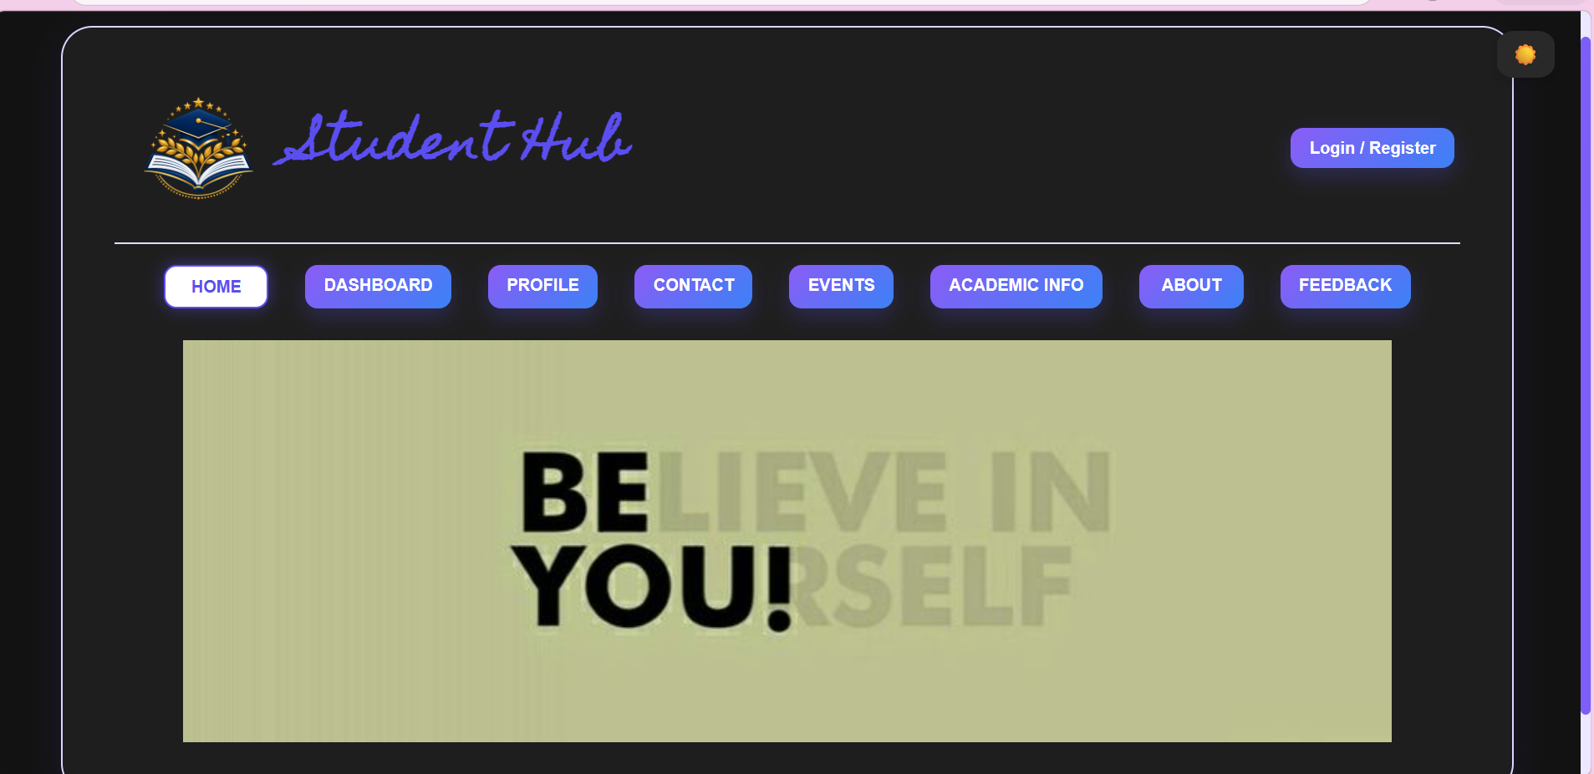

Register page:
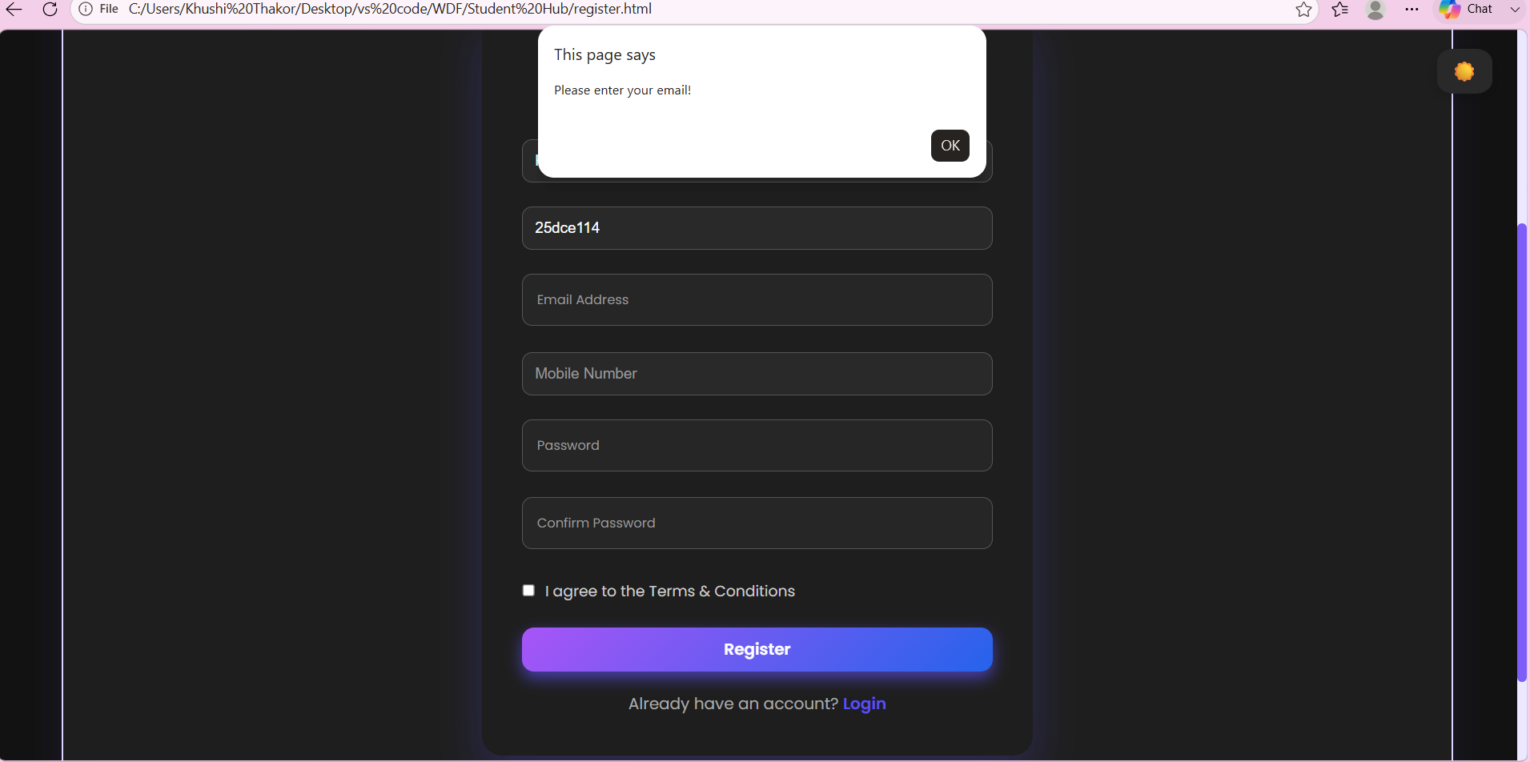
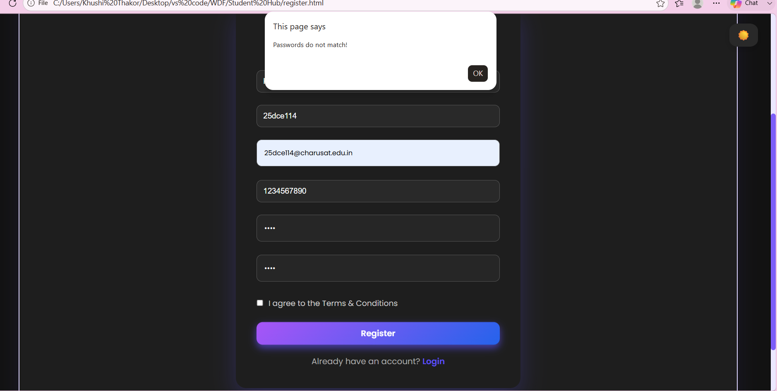
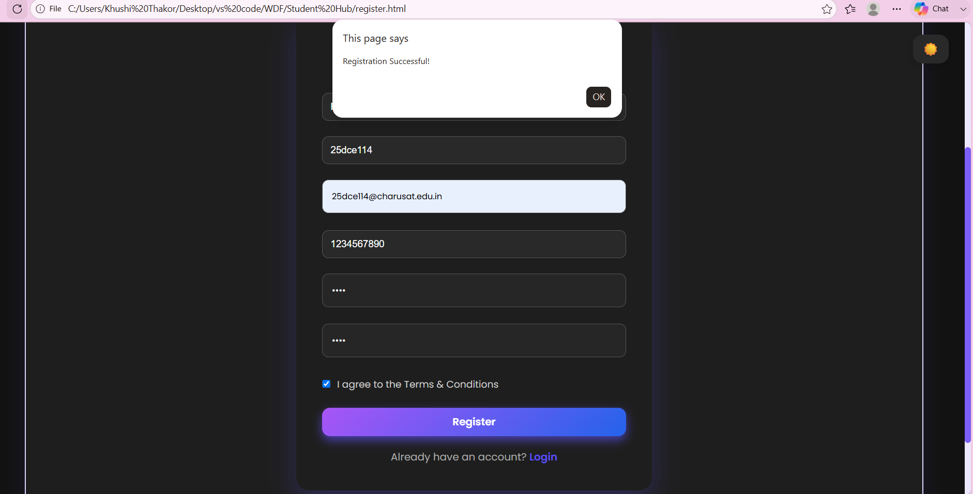
Login page:
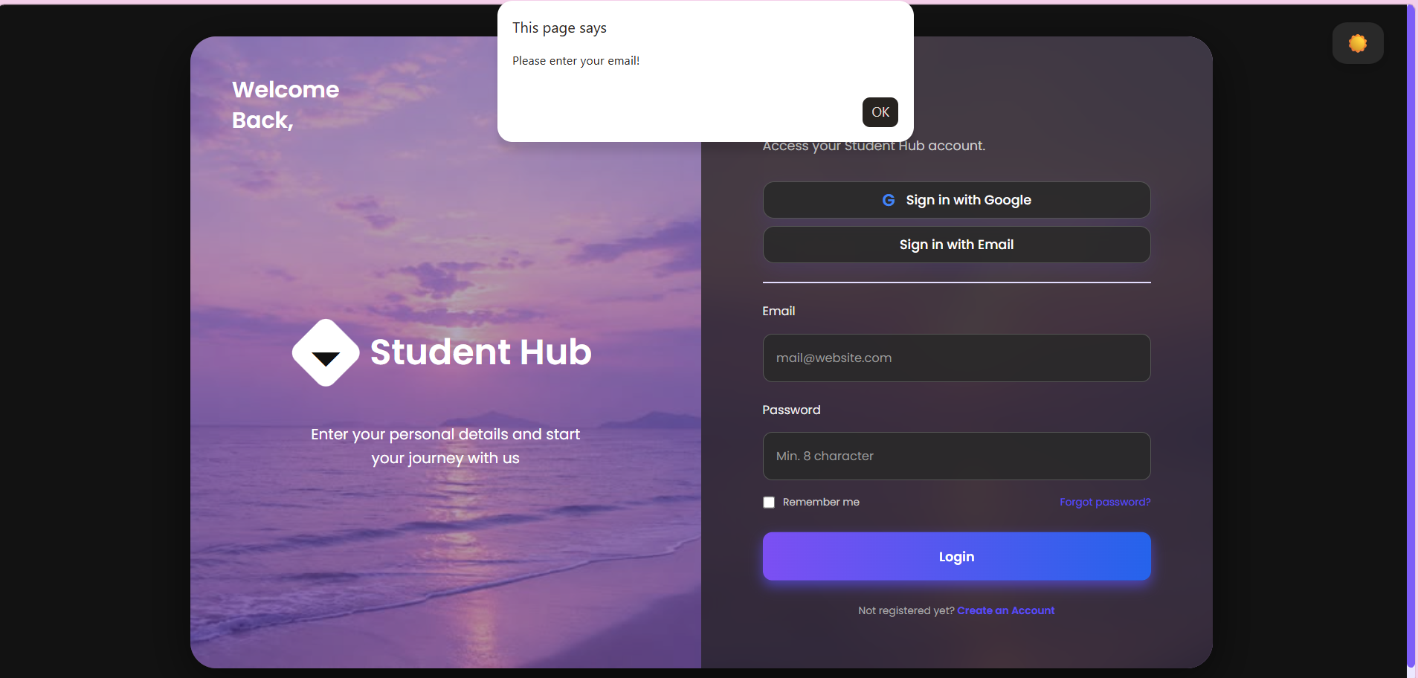
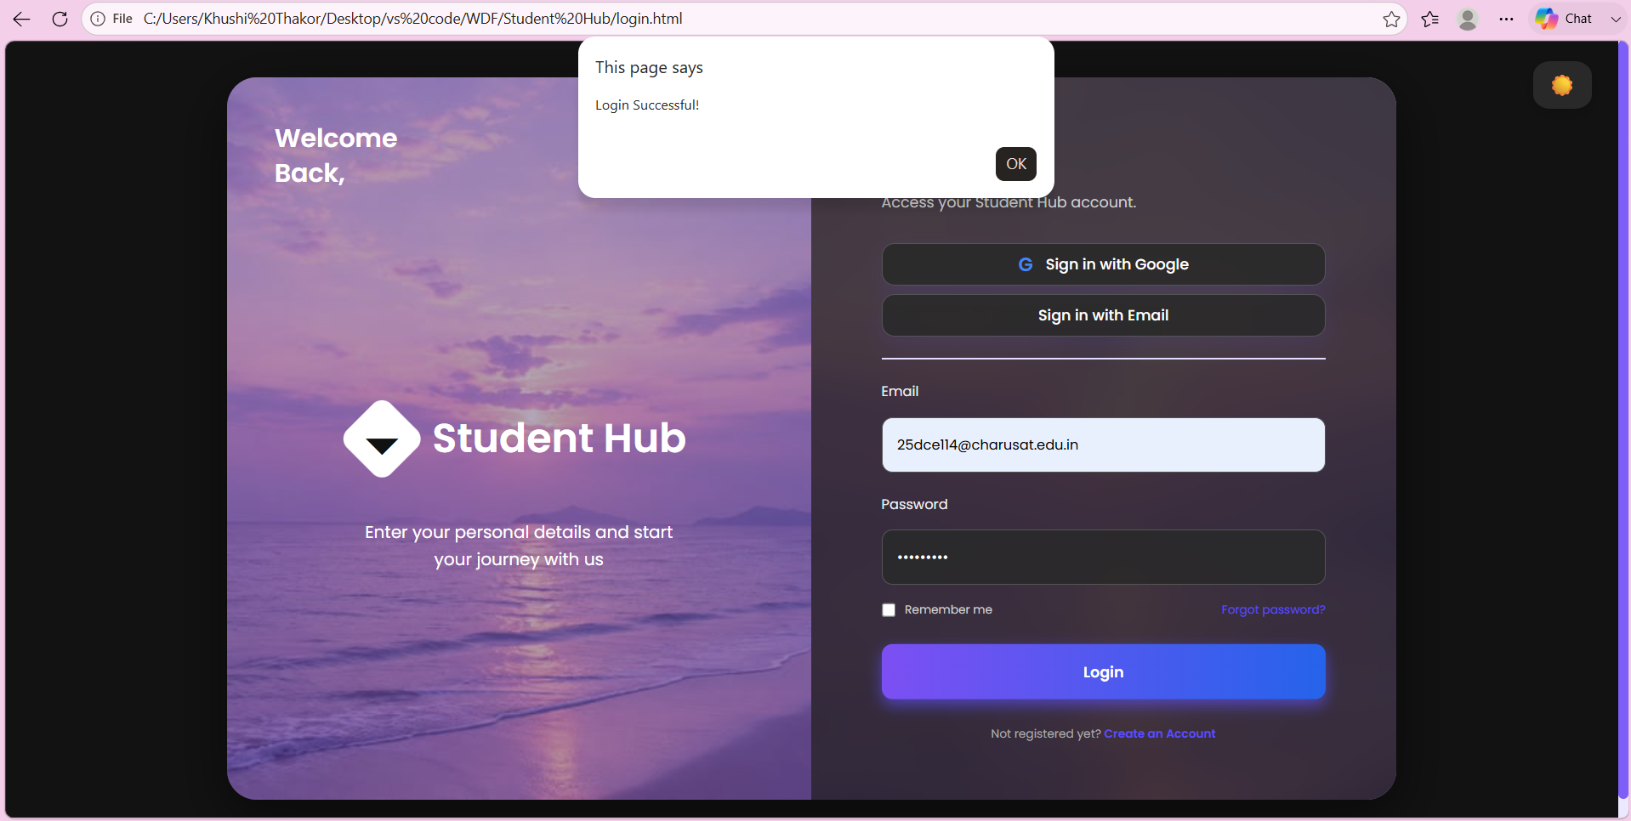
Dashboard:
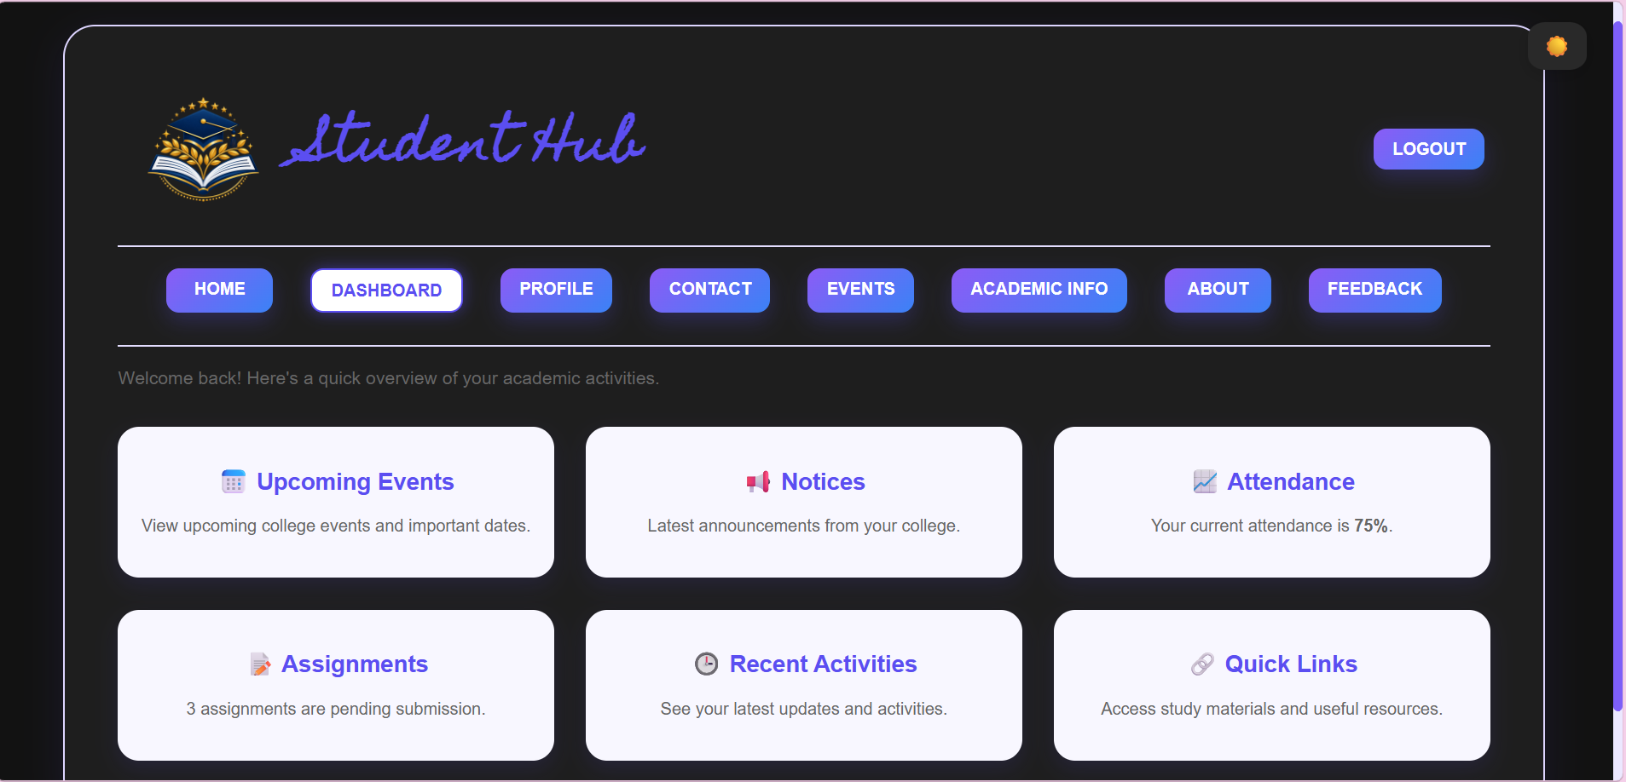
Profile:
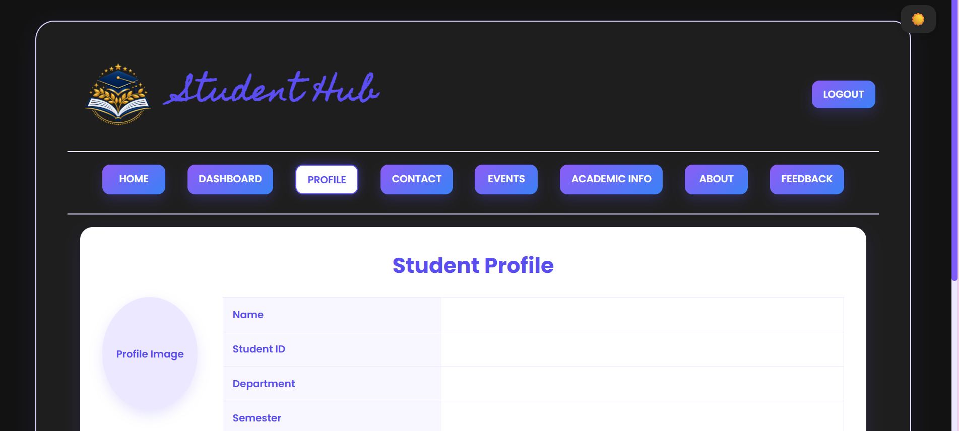
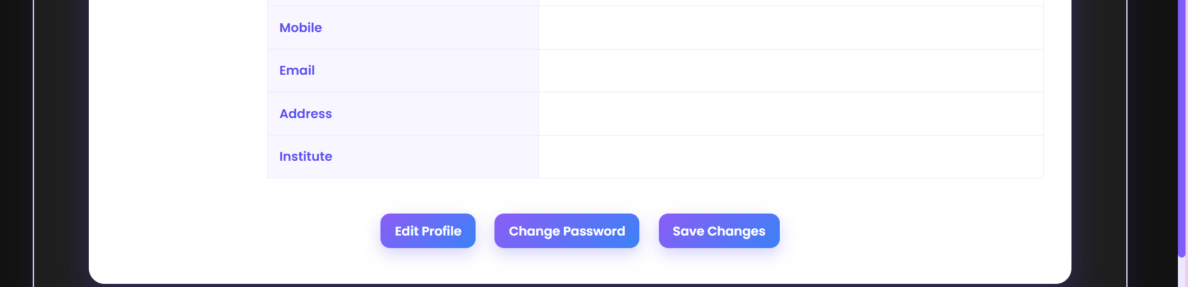
Event:
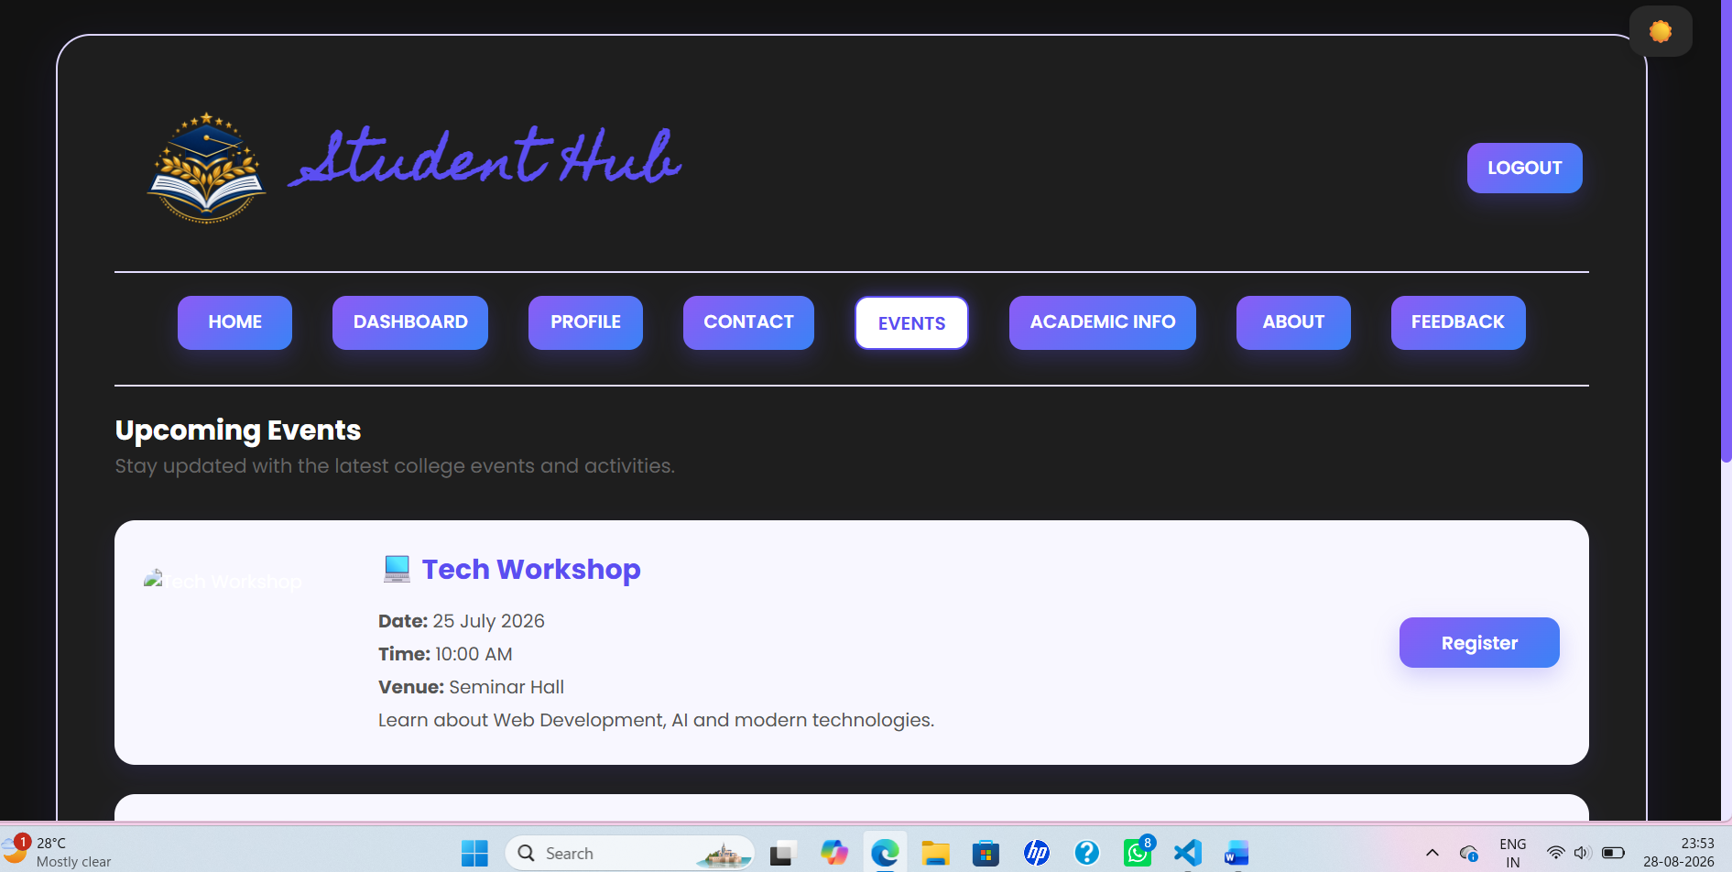Academic page:
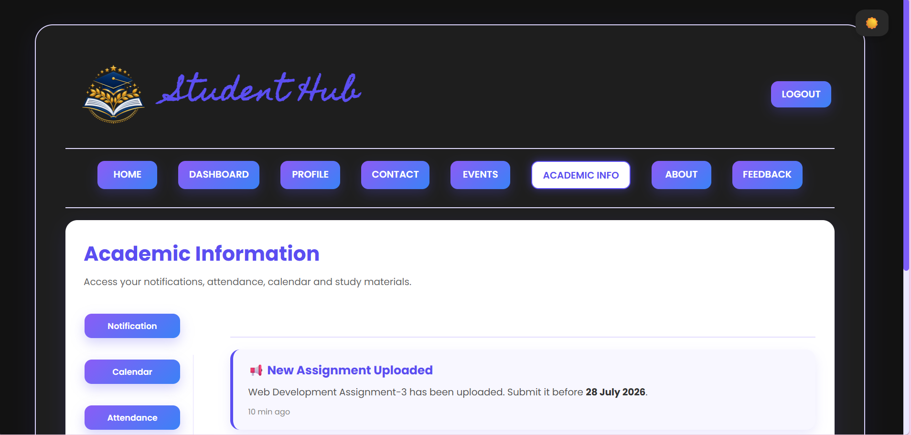
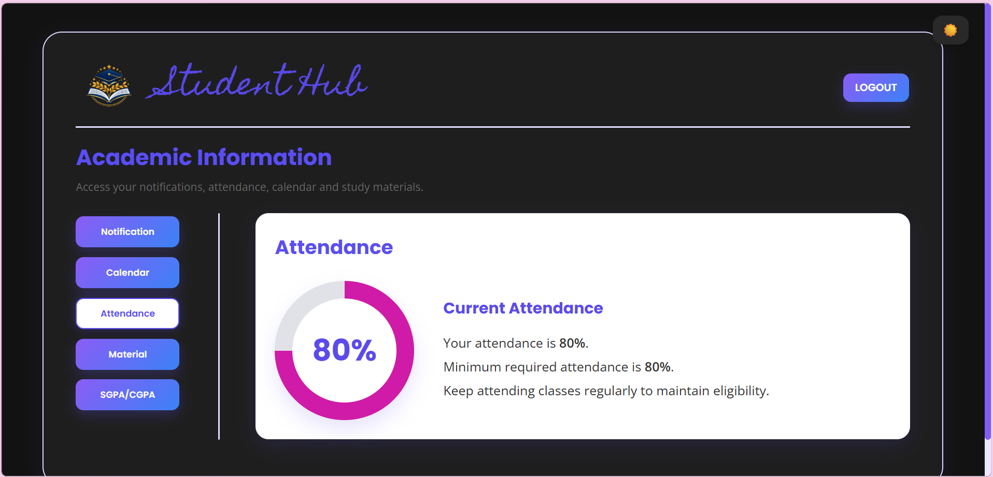
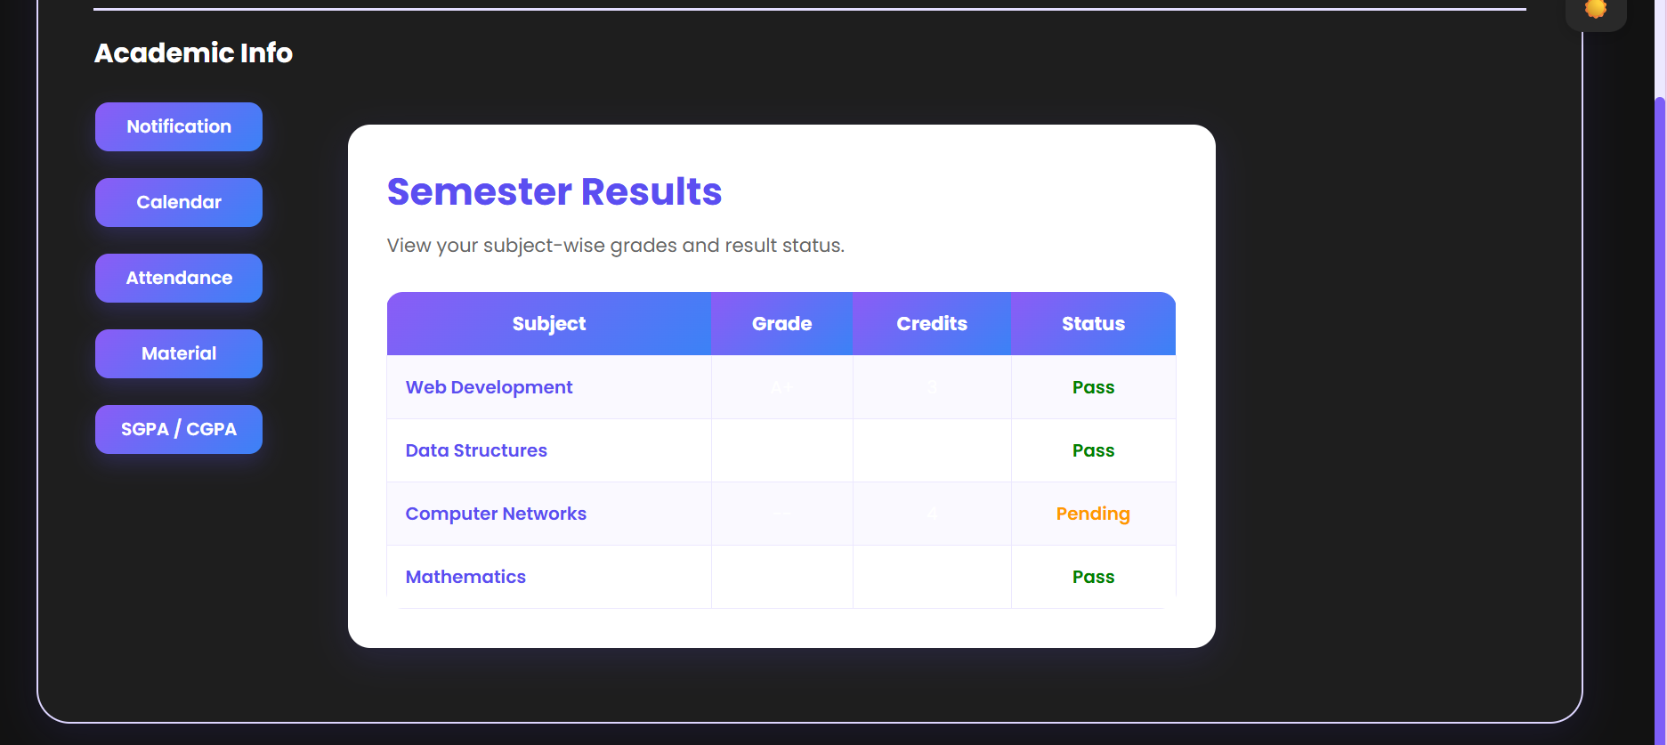
About page:
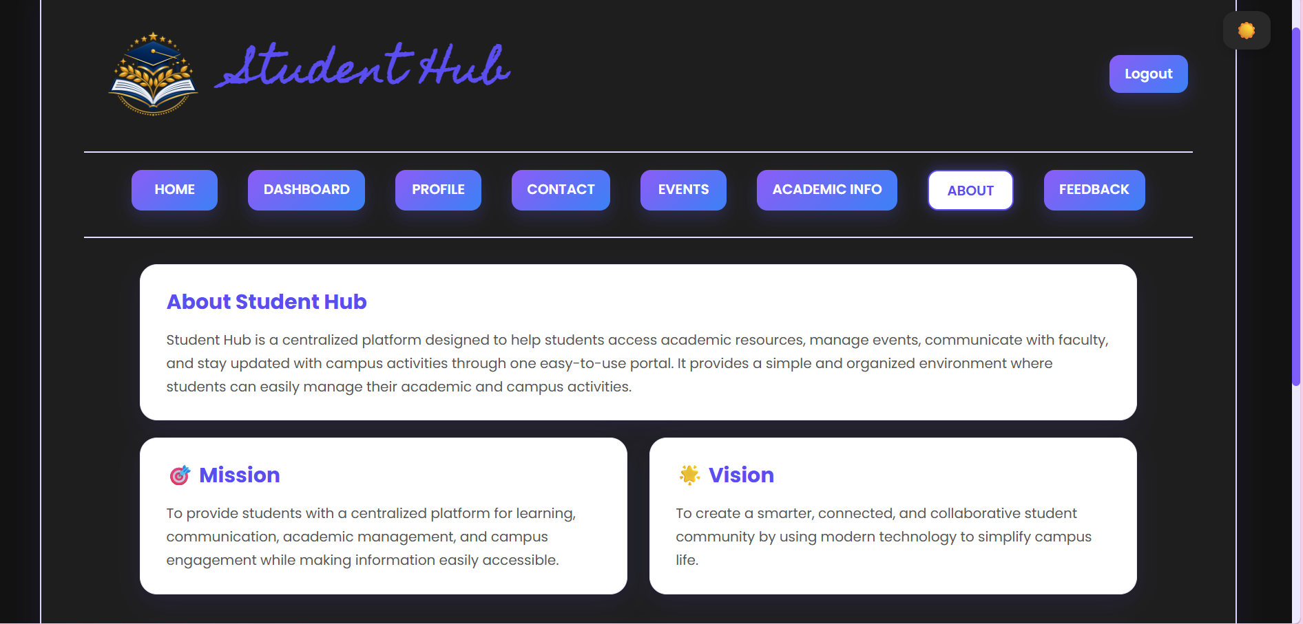

GitHub Repository Link:
Khushi-Thakor2007/Student-Hub-Portal

Challenges Faced:
I have faced the problem in inserting the dark-light mode toggle.

Learning Outcomes:

I learnt basic js and some formatting tags and toggle for the theme.

Faculty Remarks:

